Assignment No. 01

Name: Joyce Joseph
Roll No.: BI30

Problem Statement:
Implement multi-threaded client/server Process communication using RMI.

Tools / Environment:
Java Programming Environment, jdk 1.8, rmiregistry

Theory:
RMI facilitates communication between Java applications deployed on separate servers and connected remotely via objects known as stubs and skeletons. This architectural setup simulates distributed application behavior, where objects interact over remote connections. These objects are encapsulated, exposing interfaces that provide access to their private state and behavior through methods.
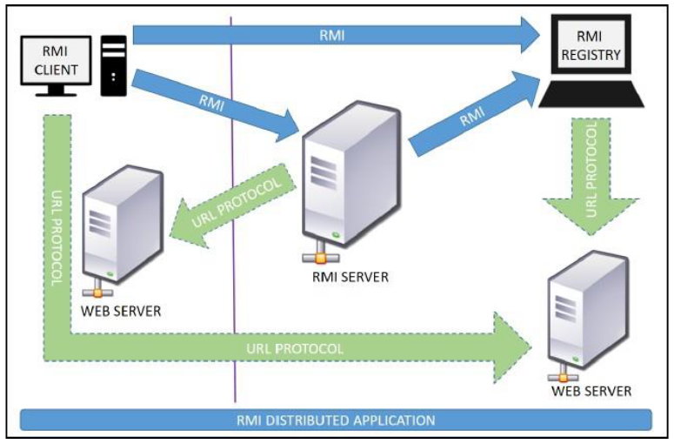
The RMI registry serves as a remote object registry and bootstrap naming service, utilized by the RMI server on the same host to bind remote objects to names. Clients, both local and remote, then look up these remote objects and execute remote method invocations.

Key RMI terminologies include:

Remote object: An object in a specific JVM whose methods are exposed for invocation by programs on different JVMs.
Remote interface: A Java interface defining methods existing in a remote object. A remote object may implement multiple remote interfaces.
RMI: A method for invoking remote object methods through a remote interface, resembling local method invocation syntax.
Stub: A Java object serving as an entry point for client objects to route outgoing requests to the remote object. It resides on the client JVM.
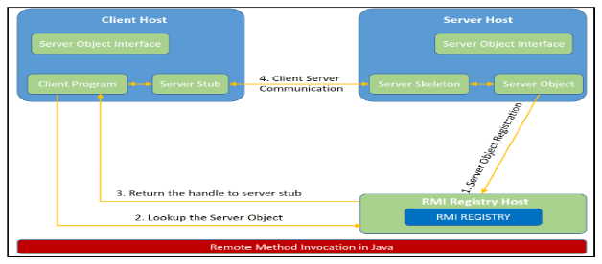
When a method is invoked on the stub object, it establishes RMI by:

1. Initiating a connection to the remote JVM.
2. Marshaling (writing and transmitting) parameters to the remote JVM.
3. Waiting for a response from the remote object, then unmarshaling (reading) the result or exception, and responding to the caller accordingly.

A skeleton acts as a gateway on the server side, interacting with client objects through the stub. It follows similar steps to establish RMI, including reading parameters, invoking the remote object method, and marshaling the result back to the caller.

Designing a solution with RMI involves:

1. Designing and implementing components involved in both distributed and local applications.
2. Ensuring accessibility of components participating in RMI calls across networks.
3. Establishing network connections between applications requiring RMI interaction.

The remote interface definition is crucial, declaring methods available for invocation by remote clients. Implementing the solution involves creating a remote interface, implementing it, and developing server-side and client-side programs.

The solution is implemented by building an application for performing various mathematical operations. The server receives client requests, processes them, and returns results. Necessary stubs are generated, files are installed on client and server machines, the RMI registry is started on the server, and both server and client are initiated to execute the application.

Code:
MyServer.java:
import java.rmi.*;
import java.rmi.registry.*;

public class MyServer{

public static void main(String args[]){
try{

Adder stub=new AdderRemote();
Naming.rebind("rmi://localhost:5000/sonoo",stub);

}catch(Exception e){System.out.println(e);}
}

}

MyClient.java:
import java.rmi.*;

public class MyClient{

public static void main(String args[]){
try{

Adder stub=(Adder)Naming.lookup("rmi://localhost:5000/sonoo");
System.out.println(stub.add(38,4));

}catch(Exception e){System.out.println(e);}
}

}

AdderRemote.java:
import java.rmi.*;
import java.rmi.server.*;

public class AdderRemote extends UnicastRemoteObject implements Adder{

AdderRemote()throws RemoteException{
super();
}

public int add(int x,int y){return x+y;}

}

Remote.java:
import java.rmi.*;
public interface Adder extends Remote{

public int add(int x,int y)throws RemoteException;
}

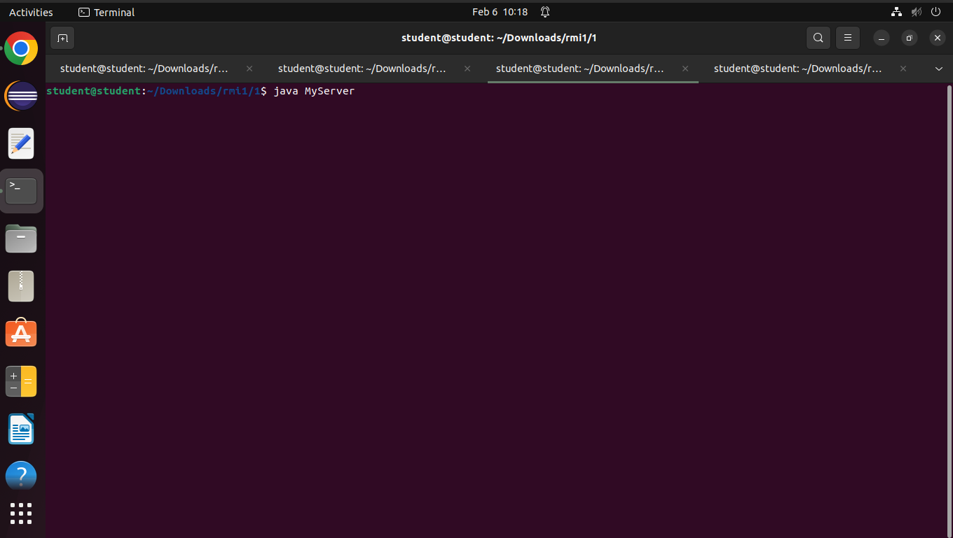
Output:

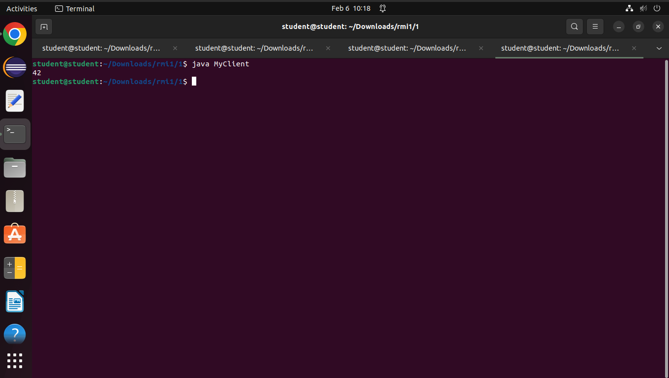
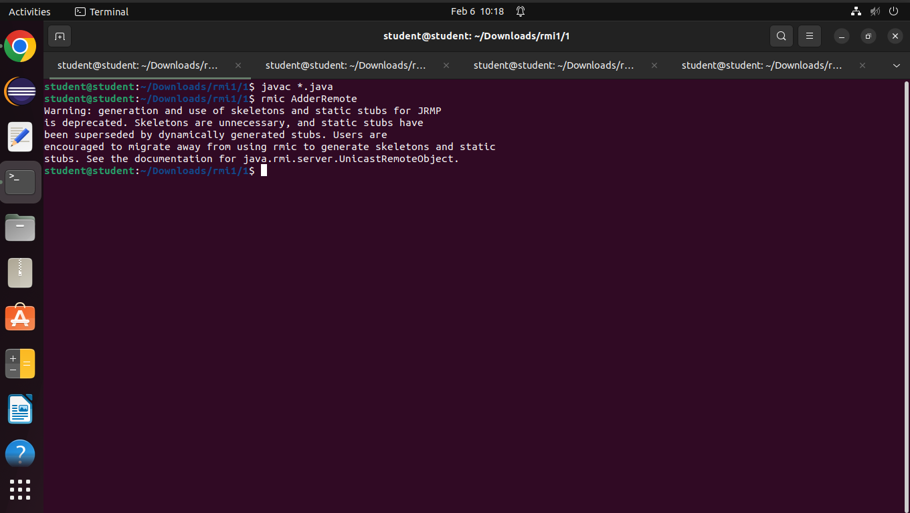

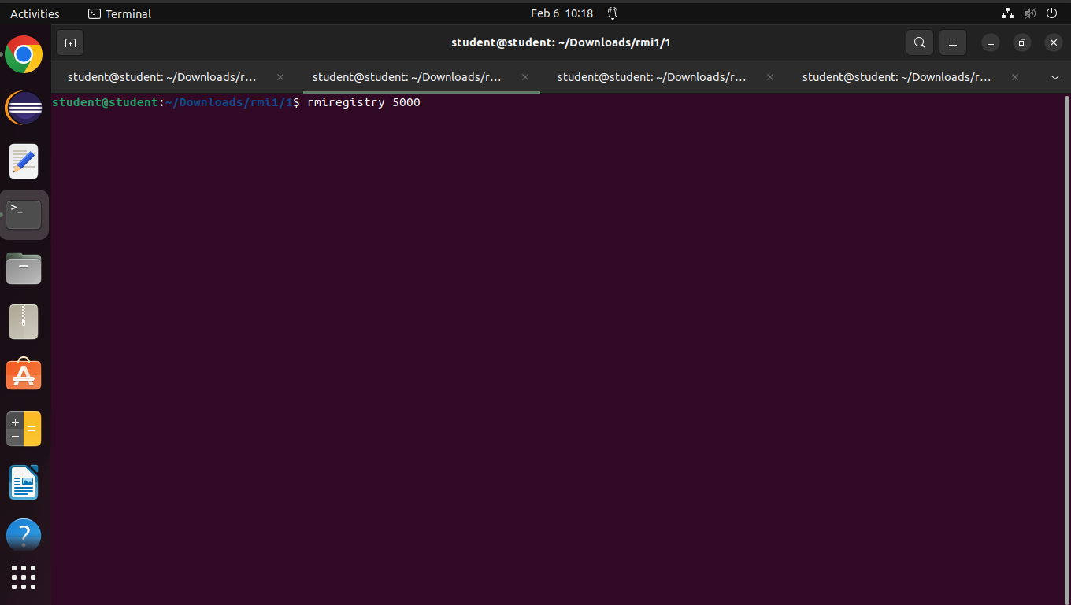

Conclusion:
Remote Method Invocation (RMI) enables the creation of Java applications spread across multiple machines. With RMI, a Java object running on one machine can call a method of a Java object running on another machine. This capability is significant as it facilitates the development of distributed applications.

